Analog Engine
Example Applications
This document includes examples of applications realized with an analog engine.
Author: Dietmar Hiller
License: CC BY-NC-SA 4.0 (https://creativecommons.org/licenses/by-nc-sa/4.0/ )
Version History
‍2024-09-23 | Some rearrangements; Throwing a stone on earth, starting a rocket from earth | Dietmar Hiller
‍2024-09-10 | Application: Potential of a charged sphere | Dietmar Hiller
‍2024-08-19 | Application: Gravity 2-dim | Dietmar Hiller
‍2024-07-24 | Application: Gravity | Dietmar Hiller
‍2024-07-16 | Applications: Quantum mechanics: Quantum well | Dietmar Hiller
‍2024-07-05 | renamed DELACE to LACE; Applications: Masses hanging on springs; 2 masses fixed to walls; linear molecule | Dietmar Hiller
‍2024-06-05 | Application: Bead glides on cycloidic wire | Dietmar Hiller
‍2024-05-29 | Applications: Hollow Cylinder; Rope on Edge of Table | Dietmar Hiller
‍2024-02-25 | Application: Falling Mass | Dietmar Hiller
‍2024-02-16 | Application: Mass in Tube | Dietmar Hiller
‍2024-02-05 | Application: Comet on parabolic orbit | Dietmar Hiller
‍2024-02-01 | Harmonic Oscillator basics | Dietmar Hiller
‍2024-01-31 | corrected 10¹ is da (deca)  License CC BY-NC-SA  Application: 2 raindrops | Dietmar Hiller
‍2024-01-24 | Some general details  Mass at the apex on a sphere | Dietmar Hiller
‍2024-01-16 | Added: Mass with charge in e/m field | Dietmar Hiller
2024-01-08 | Separated Helper Functions and Scaling to “Technical Topics”; Moved code to separate files AESL; Analytical solution of the damped harmonic oscillator; Scaling amplitude and time | Dietmar Hiller
2023-10-06  :  2023-10-04 | Adapt to updated syntax: OUT.U; use of ALIAS; corrected usage of operation time: OP-TIME instead of SPEED; damped harmonic oscillator; | Dietmar Hiller
2023-09-24 | First draft | Dietmar Hiller
Table of Content
1. Classical Mechanics 2
1.1. Gravity on Earth 2
1.1.1. Throwing a Stone 2
1.1.2. Falling Mass 3
1.1.3. Two raindrops 4
1.1.4. Rope on Edge of Table 5
1.1.5. Mass at the apex on a sphere 6
1.1.6. Mass in tube 7
1.2. Gravity in Space 9
1.2.1. Simple 1-dimensional case 9
1.2.2. 2-dimensional case 9
1.2.3. Comet on parabolic orbit 11
1.2.4. Starting a Rocket 13
1.3. Harmonic Oscillator 17
1.3.1. Undamped 17
1.3.2. Damped 18
1.3.3. Hollow Cylinder 20
1.3.4. Bead glides on cycloidic wire 21
1.3.5. Longitudinal Oscillating Chains 23
2. Quantum Mechanics 26
2.1. Quantum Well 26
3. Radioactivity 27
3.1. Radioactive Decay 27
4. Electrodynamics 28
4.1. Mass with charge in em field 28
4.2. Potential of a charged sphere 29
5. Notes 30

Classical Mechanics

Gravity on Earth
The gravitation potential created by a mass M is
.
The acceleration of a mass m in this potential is

Also important for the problem is initial position and initial speed .

Throwing a Stone
On earth the gravitation acceleration for events close to the surface is summarized as
,
with M_{E} the mass of earth and R_{E} its radius. This simplifies physics. It is valid for r not too far from R_{E}.
Throwing a stone can thus be easily described by

The script to calculate the trajectory is in file “EP1 871102 Throwing a stone.LACE”.
Scaling is required in order to represent g=9,81 m/s². This is simply done by using da*m (10¹ m) for the length => g= 0,981 da*m/s². Time scaling is done through the integration constant of the system, here 1 ms.
Constants:
- g = 0,981 da*m/s²
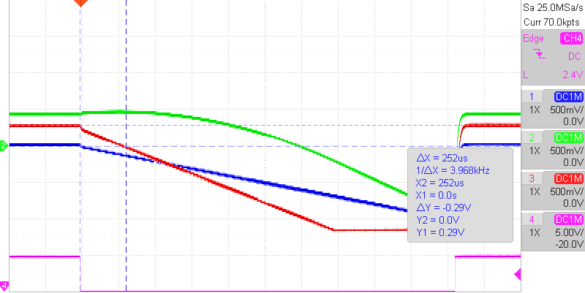
- v_{z0} = 0,258 da*m/s
- v_{x0} = 0,492 da*m/s
- z₀ = 0,417 da*m
Altitude green, v_{z0} red (initially positive, after 0,252 ms_{engine time} (0,252 s in application time) reverses direction due to gravity), v_{x0} blue (constant).

Falling Mass
Calculate the deflection from the vertical caused by the Earth's rotation of a mass falling freely from rest from a height h.
Since the earth is a moving reference systems, the full equation of motion is
.
On earth, ω ist constant, thus ω̇ = 0.
Furthermore, and ω² ≈ 0, which results in the equation containing just the Coriolis force:
.
Using results in this set of differential equations

with φ as the latitude of location (0-π/2).
The script can be found in “TP1 07.19 Falling Mass.AESL”.

Scaling
The rotation of earth (2π/24 h) is reflected in the constants a and b. Converting this to seconds results in a very small value (72,72*10⁻⁶). This value can be achieved by concatenating two coefficient potentiometers of which on is set to 0,01.
x and y are expected to be in cm to m whereas z is in the range of 100 m.
The solution is to measure z, ż and z˙˙ in a unit of 100 m and to remain with the other values in m. Here ż is needed to calculate x˙, so ż has to be multiplied by 100 to convert to m, which can be done by the coefficient b. It is very small so this multiplication comes very handy.
Also x˙ should be converted to 100 m by dividing a by 100. However, a is already tiny, so that we can approximate a by zero instead.

Measurements
- Where is the largest deflection?
Adjusting a and b, which contain the latitude shows that the largest deflection is with sin φ = 0, i.e. cos φ = 1, i.e. φ = 0°, i.e. at the equator.
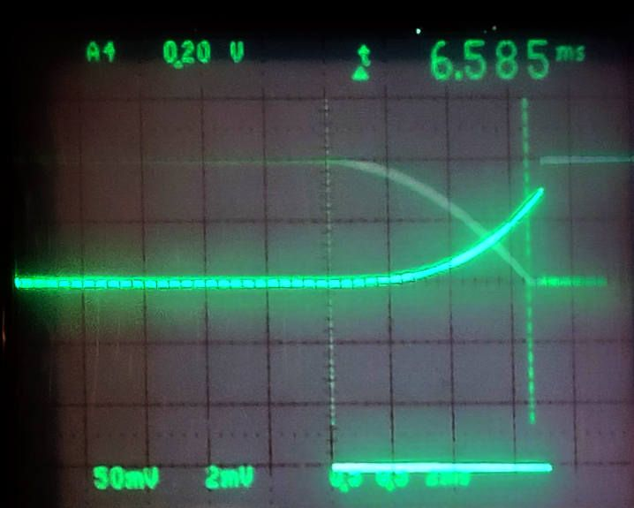
- How large is the deflection at that location?
Time to reach ground is measured to 6,585 ms (i.e. 6,585 s in the application), calculated is 6,386 s.
At that time x has the value of 63 mV (i.e. 63 mm). Calculated is 62 mm. y is still on noise level thus negligible.
At my home location with 51,7° latitude, the deflection is still at 41 mm.

Two raindrops
Two raindrops of same size and altitude are falling towards the earth. How long does it take until they touch due to the gravitational force between them?
As this is a multi-body problem, we make use of the reduced mass (1/µ = 1/m₁ + 1/m₂). This gives the differential equation

With m₁=m₂: µ=m/2, with m=m₁=m₂ thus
.
The fact that the mass is divided by 2 can be understood by the fact that both raindrops are attracting each other, thus reducing inertia.

Scaling
Looking at the values for this calculation, the need for scaling is evident:
- Radius of the raindrops: r=1mm
- Initial distance: 2 mm
- Constant of gravity: γ=6,672*10⁻¹¹ m³/(kg s²)
- Density of water: ρ=1 kg / dm³
- Mass: m=4π/3*ρ*r³=4,189*10⁻⁶ kg

First, cm are used for the lengths, which also puts the size of the drops to a usable value. However, the constant of gravity still remains too small. Next, time is measured in 10⁴ s.

Which gives the settings:
- 2r 0,200 cm
- s0 0,400 cm
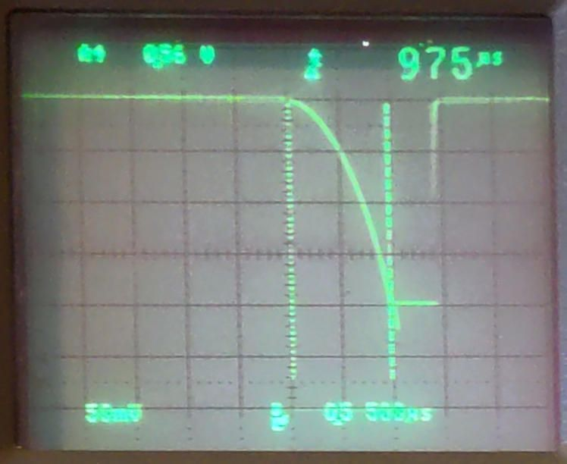
- 2gamma*m 0,056 cm³/(10^4 s)²
Timescale is: 1 Timebase = 10⁴ s

Measurement
The time until the two drops touch is measured to 975 µs.
Timebase of THAT is 1 ms, thus the measured time is 10⁴ s * 0,975 ms / 1 ms = 9750 s = 2,71 h, which corresponds to the calculated value.
AESL-Script: “TP1 04.11 TwoRaindrops.AESL”

Rope on Edge of Table
A rope (length l) slides frictionlessly down the edge of a table. Using the Lagrange-formalism to solve this problem.

The equation of motion is generated through the Euler-Lagrange equation.
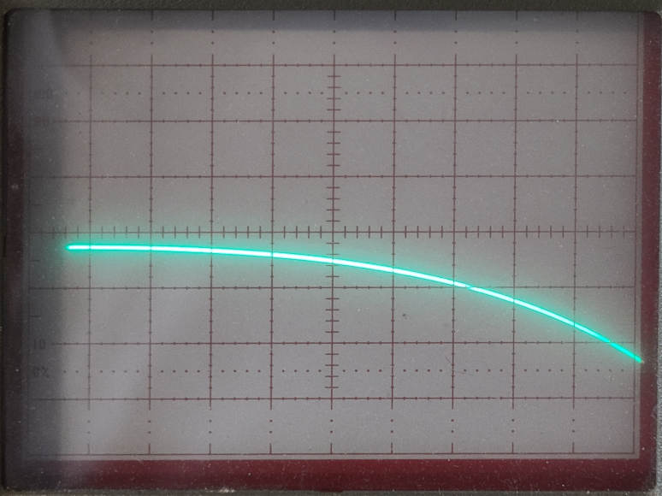Intial speed x0'=0; initial length over the edge x0=0,124; g/l=0,383

The analytical solution is .
Script: “TP1 09.26 rope over table edge.LACE”

Mass at the apex on a sphere
A mass m rests at the apex on a fixed sphere with radius a. With a slight displacement, it slides down the sphere without friction.
We are making use of Lagrange equations of the 1st kind.

Equations of motion

Calculating λ
Insertion of the equations of motion

v² is determined by the law of conservation of energy

Final equations of motion

Program
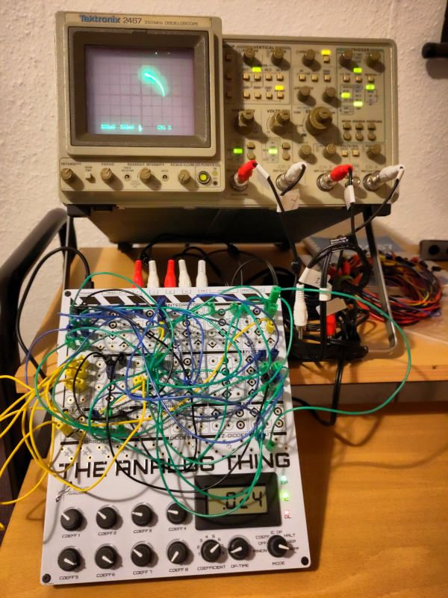
Scaling is done simply by using da-m (10¹ m) instead of meter in order to have g=0,981 da-m/s². Thus also a, x, y are measured in da-m. The constants are thus:
‍Const | Coefficient | Example | Unit
a |  | 1,000 | da-m
g | C5 | 0,981 | da-m / s²
3 g / a² | C1 (for x*y), C2 (for y^2) | 2,943 | 1 / (da-m * s²)
2 g / a | C3 (for x), C4 (for y) | 1,962 | 1 / s²
x0 | C6 (=root(a² – y0²)) | 0,957 | da-m
y0 | C7 | 0,290 | da-m
The display of the oscilloscope is extremely sensitive to these parameters and the tolerances of the potentiometers. E.g. C6=1 had to be set to get a good result.
The full program can be found in file
“TP1 04.10 MassOnSphere.AESL”

Mass in tube
A thin tube rotates at a constant angular velocity perpendicular to gravity. In this tube, a mass point moves friction-less.
Solving the problem for the position of the mass point makes use of moving reference systems, i.e. using the pseudo forces Coriolis and centrifugal force. Eulerforce is zero because of a constant angular speed.
After a lot of math, one arrives at the equation of motion , where r is the position of the mass from the center of rotation, ω the angular velocity, g the gravitational constant and φ₀ the initial angle of the tube.
The term is generated through solving the differential equation (see file “Technical Topics”). The differential equation is in polar coordinates which are converted to x,y for the display with the help of the sine / cosine pair generated above.
Program: “TP1 06.18 Mass in Tube.AESL”
Scaling is done arbitrarily because we are investigation this problem only analytically.
6 situations have been investigated

- Tube is initially horizontal
- Tube is initially vertical
- Tube is initially at an angle of 45° downwards
- Under which condition does the mass point oscillate harmonically (φ(0)=0)?
r₀=0, r’(0)=v₀=g/2ω
The behavior is extremely sensitive to the parameters. A stable oscillation was not possible to set up.
- Motion for v₀+ω*r₀=g/2ω (φ(0)=0)? v₀ and r₀ are chosen freely.
- Motion for φ(0)=0, r(0)=0, r’(0)=0?

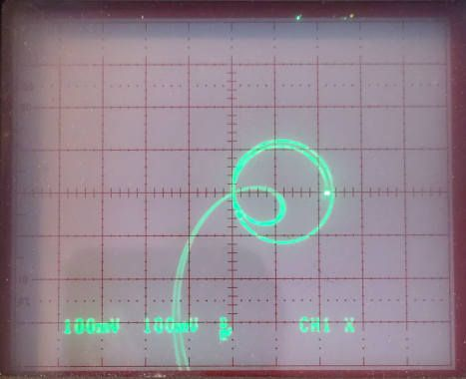 | 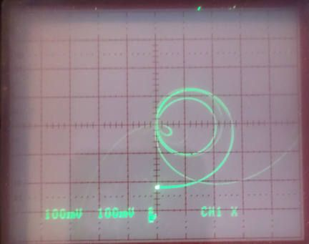 | 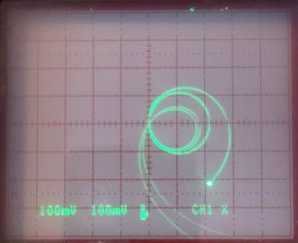
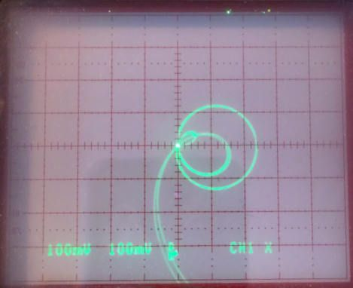 | 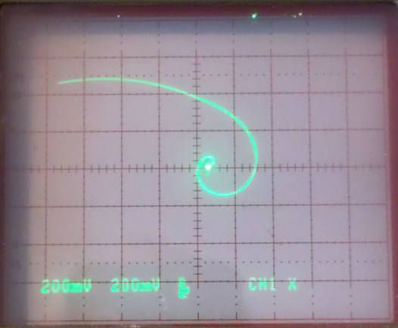 | 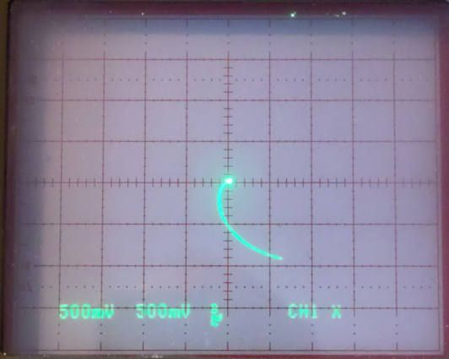

It is very instructive adjusting the various parameters and seeing the effect. Also one can see, that the behavior is near chaotic. The display shows various solutions at the same time due to fluctuations in the parameters generated by the tolerances of the electronics.

Gravity in Space

Simple 1-dimensional case
A small mass m moves along the direct line towards mass M.
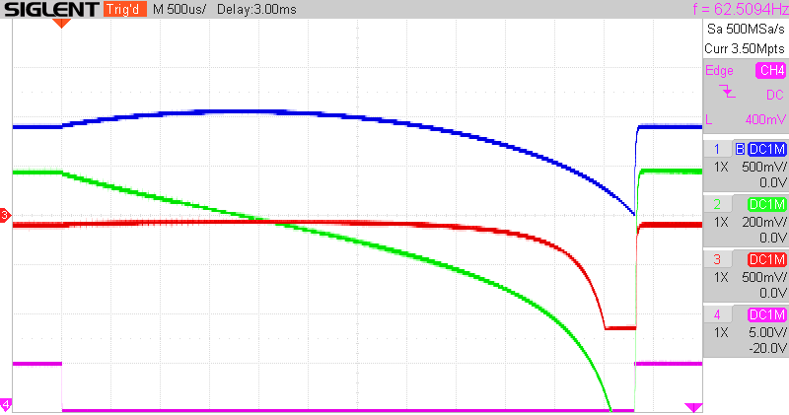v₀=+0,178; -r₀=-8,894; γ*M=+0,1;
OP-Time=5,9 ms

Additionally we have the initial postion r₀ of mass m as well as its initial speed ṙ₀=v₀ towards or away from mass M.
Script: “Gravity – 1-dimensional.LACE”
From top down: distance r from mass M (note that initially we are moving away from it), speed (initially it is positive, thus moving away, then there is a turning point were gravity takes over), acceleration (always negative, eventually it is too high for my THAT), trigger signal.
It is instructive to play with initial speed and direction and the constant γ*M and to observe position, speed and acceleration.

2-dimensional case
In the 2-dimensional approach e.g. a swing-by maneuver can be simulated. A satellite approaches a planet and with the help of its gravitation the direction and speed of that satellite can be altered. This is especially used for the exploration of the outer planets and beyond.

Cartesian coordinates

Thus

The angles are given by

This needs 4 multipliers, 2 of which are used for the division to calculate the trigonometric functions. Unfortunately, only 2 are available on my THAT. Thus, this solution cannot be implemented.

Polar coordinates
Here, the 2-dimensional situation is represented in polar coordinates. Any trajectory can be converted into this configuration.
In polar coordinates the gradient is expressed as

and the acceleration as
.
Note that
In this application the acceleration is given by

Looking first at the radial component:

Next the tangential component:

This could be easily translated into a script for an analog computer applying the initial position and speed of the satellite. However, in total 6 multipliers are needed.
Note that it is seen that the final speed of the satellite after the swing-by is identical to its initial speed. In this approach, however, the center of the coordinate system is the mass of the planet. Relative to e.g. the sun, the satellite’s speed increases by a component relative to the speed of the planet with respect to the sun.

Comet on parabolic orbit
A comet moves on a parabolic orbit in the gravitational field of the stationary sun. Its orbital plane coincides with the plane of the Earth's orbit, which is assumed to be circular. The perihelion distance is one third of the Earth's orbital radius R_{E}.
How long does the comet move within the Earth's orbit?
Placing the origin into the center of gravity and making use of the reduced mass
(1/µ = 1/m₁ + 1/m₂), the angular momentum and energy are
.
We are using plane polar coordinates

As the comet is moving on a parabolic trajectory, total energy E=0. The potential U(r) is given by gravity. At the perihelion L can be expressed by r=1/3 R_{E} and ̇r=0. Putting all together gives
.
m is the total mass of the sun plus the comet, which can be approximated by the mass of the sun only.
The integral has to be calculated from the entrance point R_{E} to the exit point at R_{E}, but due to symmetry we can use the double of the time from the entrance point to the perihelion 1/3 R_{E}. The integral is negative due to the attraction force.

This is an integral which can be solved with the analog engine.

Scaling
Scaling is performed through choosing the proper SI unit prefixes. Here tera meters and 10 kilo days.

Measurement
Script is in “TP1 05.15 Comet.AESL”.
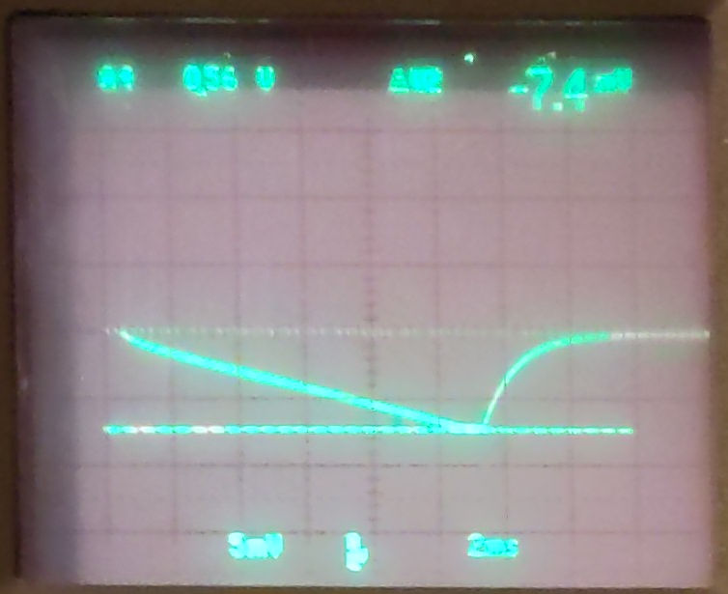
Note that the input to calculating the root is limited to negative values. It was observed an a THAT that positive values, even electro-static spikes, cause the multiplier to error out which could only be reset by un- and re-plugging the inputs to the multiplier. Thus whenever the result was unexpected, this type of reset was necessary.
The integral reaches its maximum (which is the desired value) at 7,4 mV, corresponding to 7,4 * 10⁻³ * (10 kd)= 74 days.
The calculated value is 74,78 days.

Starting a Rocket
A rocket is started from the surface of the earth. We are calculating the height as function of its mass and fuel consumption.
The momentum of the rocket is , that of the exhaust , where α is the constant change of mass of the rocket (), i.e. the burning rate of the fuel, v₀ the velocity of the exhaust relative to the rocket. Its direction is opposed to that of the rocket, thus the negative sign. The velocity of the exhaust relative to the inertial system is .
This results in the equation of motion:

Extending the case with gravity

with the values for the first stage of Saturn V [haus der astronomie]
- α the fuel consumption rate: e.g. 2114 t in 2,8 min = 12,6*10³ kg/s
- m₀ the initial mass of the rocket: e.g. Saturn V: 2938 t = 2,94*10⁶ kg
- v₀ the velocity of the exhaust of the rocket: 3180 m/s
- γ gravitational constant: 6.67430*10⁻¹¹ m³/(kg*s²)
- M_{E} the mass of earth: 5,9722*10²⁴ kg
- r the distance of the rocket from the center of earth
  - r₀ = R_{E} the radius of earth (the initial position of the rocket): 6,371*10⁶ m
According to literature, the rocket should reach an altitude of about 12 km after 1:23 minutes.
The issue is, that THAT only has 2 multipliers, here 3 are needed. So we try 2 different approaches for approximation:

Approximation of gravity with g
This approximation is only valid as long as the rocket is not too far away from the surface of earth.

with g = 9,81 m/s².

Scaling
Scaling has to be carefully chosen because we are dealing with very different orders of magnitude. Also we want to observe the flight during 2 minutes.
Finally, mass is measured in 10⁷ kg, distance in 10⁶ m and time in (2 minutes).
Script: “EP1 04.02 Starting a Rocket_a.LACE”
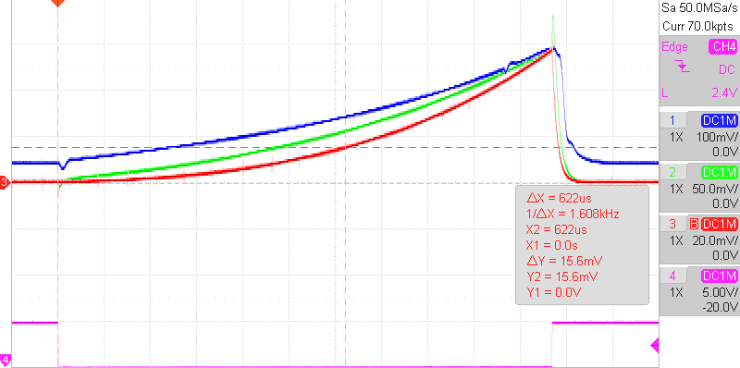
The measurement shows the increased acceleration (blue) due to the loss of mass of the rocket, the thus increasing speed (green) and the altitude (red).
The cursors were set on the x-axis such that the time ramp represents 1:23 minutes (0,69 V). Measured is an altitude at this time of 15,6 mV = 15,6 * 10⁻³ V * 10⁶ m/V = 15,6 km. We had expected an altitude of 12 km, which can be obtained by adjusting either α by -10%, m₀ by +12% or v₀ by -14%.

Taylor series for the first term
The acceleration of the rocket, the first term in the equation, can be approximated by a Taylor series:

which converges for t < m₀/α (here 233 s).

Scaling
Distance is again measured in 10⁶ m and time in 120 s.
However, for the 2. calculation of the altitude, the distance has to be measured in 10⁷ m because the radius of the earth exceeds 10⁶ m. Therefore, velocity is scaled down by a factor of 0,1 to convert to 10⁷ m (2a. Conversion of speed to 1e7 m). Thus, also γ is measured in this unit.
On the other hand, the effect of the gravity on acceleration has to be converted back again to 10⁶m. This could be done after the calculation of the second term of the equation, but it comes quite handy to anticipate the factor of 10 into the constant of γ*ME.

Script: “EP1 04.02 Starting a Rocket_b.LACE”
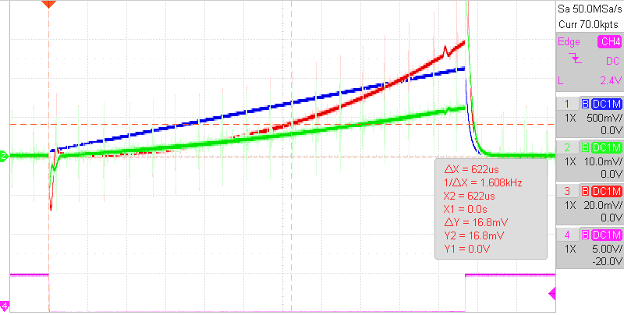
The altitude (red) is measured to be 16,8 mV, after 1:23 minutes, which corresponds to 16,8 km, quite in correspondence to the measurement using the first approach. Blue is acceleration and green the speed of the rocket.
It is very instructive to play with gravity (simulating a start from e.g. the moon), fuel consumption, initial weight of the rocket and the speed of the exhaust.

Harmonic Oscillator

Undamped
A mass m is subject to a force .
The equation of motion is

z can be set to zero.
The application is straight forward, see “TP1 04.12 Harmonic Oscialltor.AESL”.
k/m is arbitrarily set to 0,541, a to 0,568.
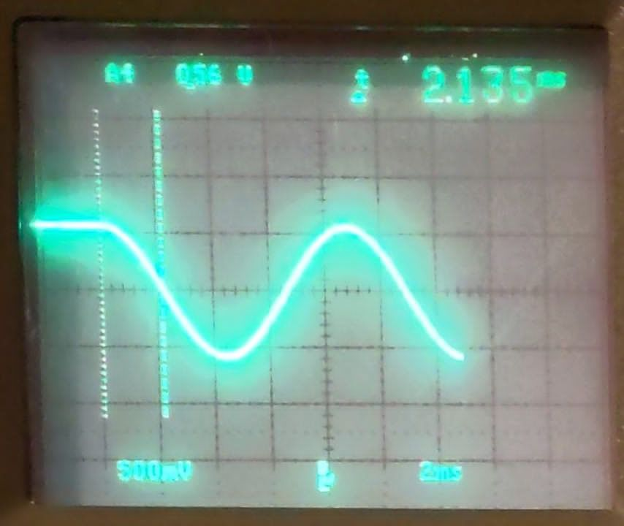
- What is its trajectory if the mass starts at position (a,0,0)?
  - The trajectory is a sine oscillation.
- At which time does it pass through (0,0,0)?
  - It passes through (0,0,0) at 2,135 s (timebase is 1 ms which corresponds to 1 s of the application).
This is in accordance to the calculated value of .
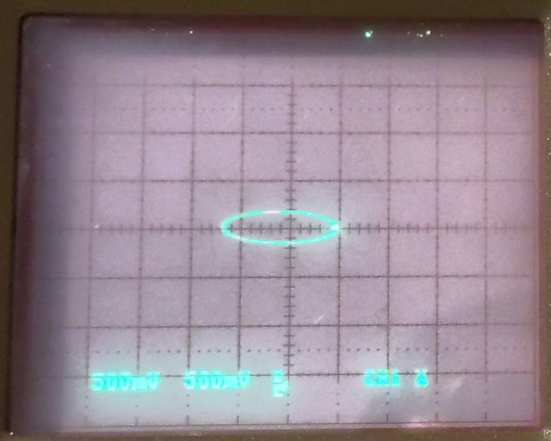
- What is its trajectory if it has additionally the initial speed (0,v0,0)?
  - It is ellipsoidal. Here v0=0,122 was used.

Damped
The equation of motion for a viscously damped simple harmonic oscillator is , with m the mass, D the damping with speed and S the spring constant.
Rewritten to y’’=-1/m * (Dy’+Sy).
An initial condition is required; we put the deflection to y0 and the speed to y0’.
Full code see “Damped Harmonic Oscillator.AESL”

Analytical Solution
[https://brilliant.org/wiki/damped-harmonic-oscillators/ ]
Solutions of the viscously damped simple harmonic oscillator should be oscillations within some form of damping envelope. Ansatz is an exponential damping envelope of an oscillation:

where A is some constant and (r = ai-g) will be found. g and a are place holders to show the damping (g) and oscillation (a). Plugging this ansatz into the equation of motion yields:

which is a quadratic equation in r with solutions:

Note that there are two roots r to the quadratic corresponding to the two general solutions:

These solutions in general describe oscillation at frequency within a decay envelope of time-dependent amplitude .
Note, the frequency of the oscillations is only depending on the spring constant, damping and mass, whereas the damping also depends on the mass.
For the undamped case (D=0) this gives

This can also be written as

Scaling
As an example, we may use the following data for the damped harmonic oscillator:
Initial Position | y0 | 1,5 m
Initial Speed | y0’ | -0,15 m/s
Spring Force | S | 2,5 N/m | kg/s²
Damping | D | 0,3 N/(m/s) | kg/s
Mass | m | 0,06 kg
 | 1/m | 16,667 kg⁻¹
Critical values are initial position (1,5 m) and 1/m (16,667 kg⁻¹). Spring force could be coped with by using a gain 10 input.
Please see the table below while following the description of the following steps.
First we take care of y0. We replace the length measured in meter with 10¹ meter, thus we make use of deca-meter. y0 and y0’ have to be adapted. See columns “deca-m” below. Spring Force and Damping remain unchanged because in base units the length gets canceled out.
Next issue is that 1/m is well above 1. We are representing the weight by 10⁻² kg, so 10¹ grams (deca-g). See columns “deca-g”. This also influences spring force and damping, which now exceed our target range.
Now, the second is replaced by 10⁻¹ (deci-s) seconds resulting in the columns “deci-s”. Note that this also performs time-scaling, so that one time-unit of the analog engine now corresponds to one deci-second instead of one second before.
After the last scaling we have the issue that y0’ is very close to zero. There are more advanced scaling techniques which manage to optimize the value range of each operational amplifier. For instance the initial speed is converted to a value very close to zero, which is not the optimal.
The fully scaled program can be found at “Damped Harmonic Oscillator scaled.AESL”. Note that the gain 10 inputs are used for SUMMER.2 in order to achieve damping and spring constant values:

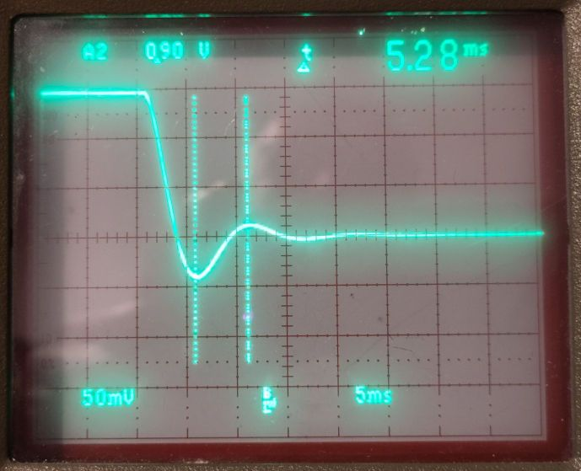Obtained damped oscillation with parameters above
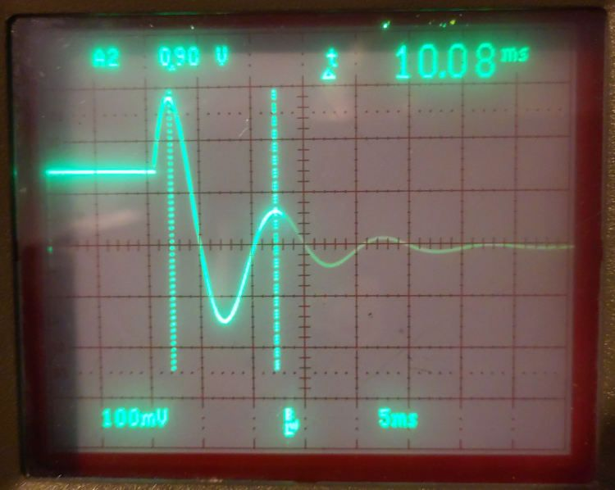Adapted parameters: D=1,69, y0'=-0,187; calculated T=9,97 ms

Hollow Cylinder
A homogeneous hollow cylinder (mass m, ration inner to outer radius ε) is connected to a massless spring (constant λ). The system is deflected from its rest position by the distance a. The cylinder rolls without sliding.
Using the energy to obtain the equation of motion.

Script: “TP1 08.22 Hollow Cylinder.AESL”
The various configurations are shown below:
Case “tiny wall” has an infinitesimally small wall thickness, “full” is a full cylinder. Same as “70% empty” all have the same mass, thus the density varies accordingly. The last case “70% empty (d)” has the same density as “full” thus the mass is reduced, which results in a reduction of the periodicity.
Periodicity is calculated as . Note that the timebase of the analog engine is 1 ms, which corresponds to 1 s in the real world.

Bead glides on cycloidic wire
A bead glides frictionless on a wire that has the shape of a cycloid (. a is the radius of the rolling circle (see Bronstein/Semendjajew p. 91).

Lagrange-Equation

Equation of motion
Using the Euler-Lagrange equation to generate the equation of motion:

Analysis
Unfortunately, the analog engine on hand cannot work with trigonometric functions. But fortunately substituting gives the well known equation for a harmonic oscillator
with the periodicity
Comparing with that of a mathematical pendulum , the similarity is evident. However, the oscillation on the cycloid trajectory is valid for all , whereas that for the harmonic pendulum requires , i.e. it is only valid for very small angles.

Visualization
Displaying µ as function of time simply shows the well known sinusoidal curve.
Following is a trial, with some admittedly brute force approximations, to show the cycloid curve instead. Thus x and y have to be calculated as function of µ.
First y:

Calculating x needs these before mentioned approximations:
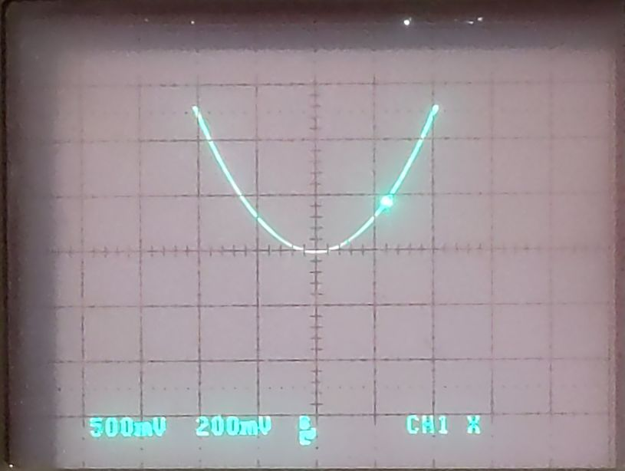
Surprisingly, the display shows something looking similar to a cycloid.
Script: “TP1 09.27 Bead on Cycloid.LACE”

Longitudinal Oscillating Chains

Masses hanging on springs
Two identical masses m are hanging on 2 springs with same spring constant D. The system is performing small oscillations around the equilibrium position.
The equations of motion are:

Script: “TP1 10.28 Masses hanging on springs.LACE”
The following images are showing the oscillations with a ratio D/m=0,5 and an initial position out of equilibrium of a) both masses with “same” magnitude in the same direction and b) in opposite direction.
In order to achieve these nice images, which show the two Eigenfrequencies of the system, the initial positions had to be tuned out of “same” target value of 0,56, which is probably due to imperfections of the THAT: a) s_{1,0}=0,46; s_{2,0}=0,75; b) s_{1,0}=0,56; s_{2,0}=0,39. Periodicities are measured to 14,3 ms and 5,6 ms which correspond to the Eigenfrequencies of 0,44 Hz and 1,12 Hz (timebase 1 ms of THAT corresponds to 1 s in the real system). Calculated values are 0,44 Hz and 1,13 Hz ( ).
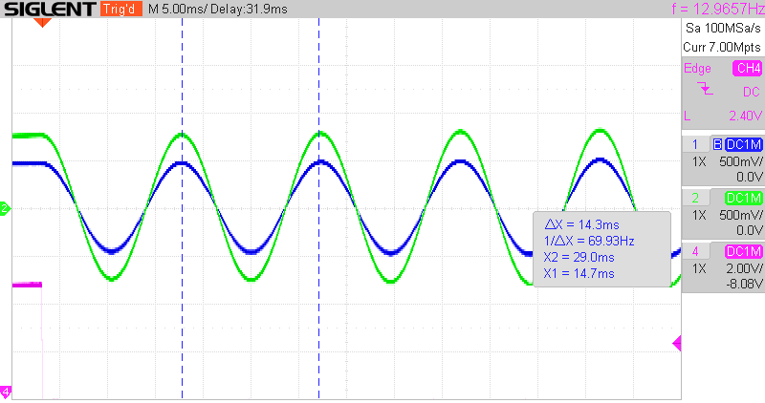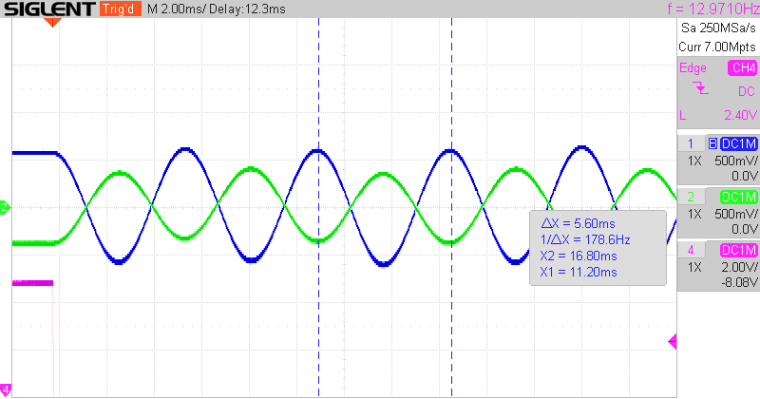

Two masses fixed to walls
Two equal masses m are connected to each other by a spring (spring constant D) and on either side to a fixed wall.
This is a modification of the application of Partial differential equations, which basically simulates an infinite number of masses with negligible distance.
The equations of motion are:

Script: “TP1 10.29 Two masses fixed to walls.LACE”
The left image shows both masses swinging in the same direction, the right in opposite direction.
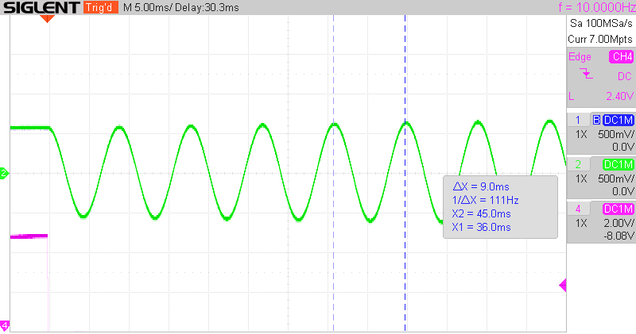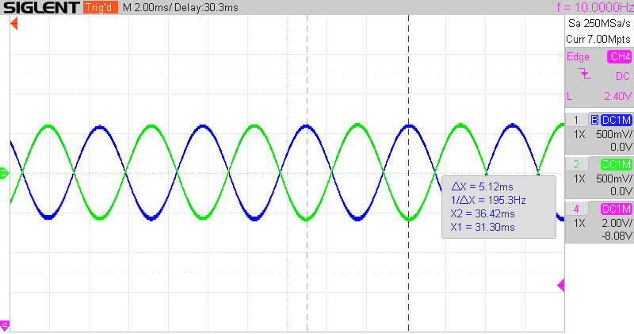
Oscillation periodicity is measured (9,0 s; 5,12 s) to be very close to the theoretical values (8,84 s; 5,10 s) ().

Linear Molecule
In a linear molecule of symmetric construction of type A-B-A the atoms are harmonically coupled and are performing small oscillations around the equilibrium positions.
The equations of motion are:

Script: “TP1 10.30 Linear Molecule.LACE”
Some configurations to try:
- Calculation predicts that the oscillating frequency ω₀ for the case where both outer atoms are moving in the same direction is .
- Amplitude of the center atom is predicted to be 2µ lower than that of the extreme atoms. Thus this amplitude can be larger, equal or smaller than that of the outer atoms.

Example CO₂
Carbon-dioxide is such a linear molecule. According to literature, the “antisymmetric” stretch (both O atoms are moving in the same direction) has a frequency of 2345 cm⁻¹ => ω₀=4,42x10¹⁴ 1/s.
ω₀² is scaled down by division by 2x10²⁹ giving ω₀²=0,977.
Carbon has an atomic weight of ~12, Oxygen of ~16, resulting in µ=16/12=1,33=0,133*10.
With these parameters and with an initial deflection of +/-0,5 for the O molecules the following behavior is observed:
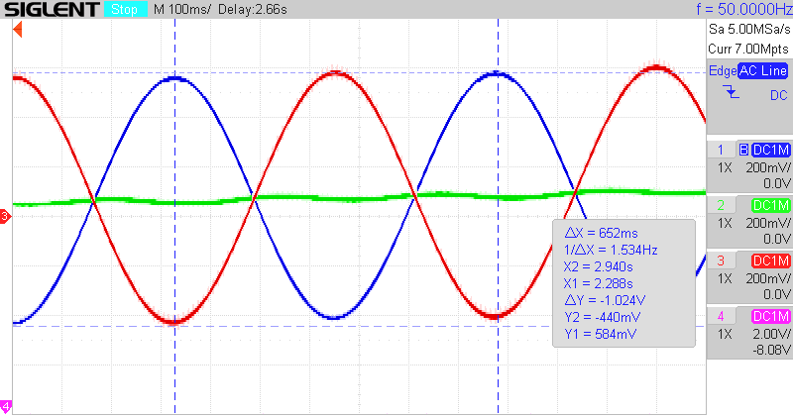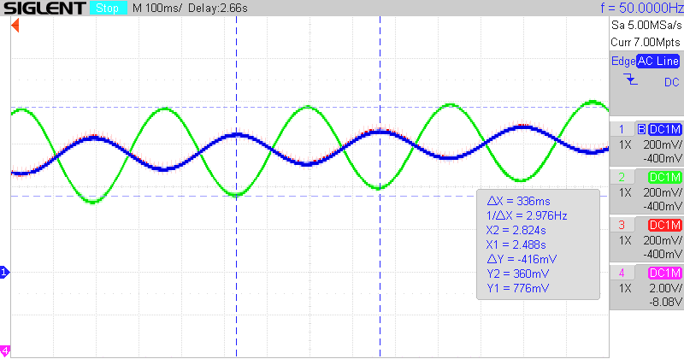
The left image shows the anti-symmetric oscillation. Periodicity is 652 ms (machine units) which corresponds to 6,52 s. Given the angular frequency above this coincides well with the calculated value of 6,36 s. Amplitude of the oscillation of the two O-atoms (blue and red) is equal and the central C-atom remains fixed.
The right image shows the situation where both O atoms are moving in the same direction. C moves opposite, thus the phase shift of 180°. Periodicity is measured as 338 ms (machine units), thus 3,38 s. According to theory, this oscillation is calculated to be . In our case the frequency here is 1,913x ω₀ , periodicity thus reduced by 0,522 giving an expected value of 3,32 s. Amplitude of the center atom is predicted to be 2µ (2,66) lower than that of the extreme atoms. Measured is ~2,5.

Quantum Mechanics

Quantum Well
Visualize the wave functions of a quantum well. This is a realization (with adaptations and corrections) of the application note alpaca_22 from https://analogparadigm.com.
Schrödinger’s equation is:

with V(x) the quantum well and E the (negative) energy of the particle.
Solving for the highest derivative yields

The implementation is in file “alpaca22 Quantum Well.LACE”.
Two solutions have been found. The size of the quantum well was made symmetrical and psi₀ was set such that no overflow occurred. Note, that the parameters have to be tuned to get the wave function continuously differentiable:
Coefficient | Name | Meaning | Solution #1 | Solution #2
1 | l | QW left boundary | 0,549 | 0,549
2 | r | QW right boundary | -0,439 | -0,439
3‍ | U0 | QW depth | 0,628 | 0,628
4‍ | epsilon | energy of system | -0,008 | -0,294
5‍ | psi’0 | psi’ init. cond. | 0 | 0
6‍ | psi0 | psi init.cond | -0,190 | -0,190
7‍ | - | not used
8‍ | slowing_t | tuning of t for QW | -0,125 | -0,125

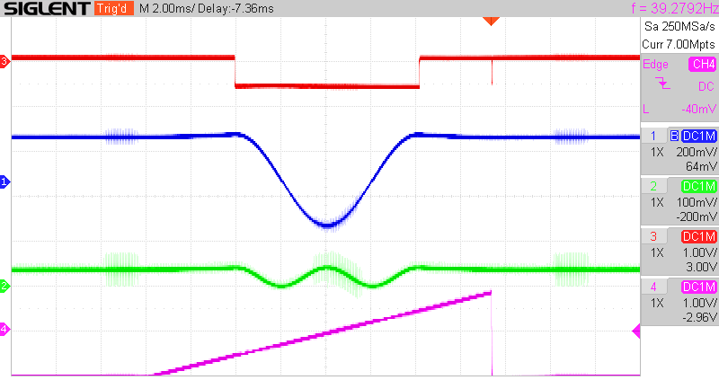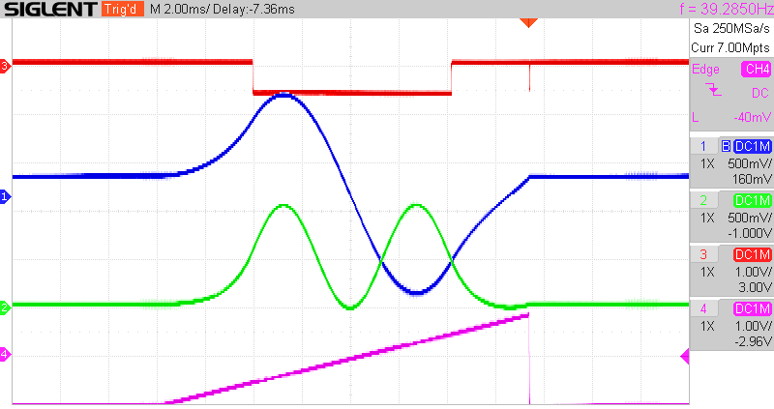
Bottom line shows the time ramp, also used as trigger. It only has an effect on the quantum well. The top line shows the quantum well, below the wave function and further below its square.
First is the wave function with a lower energy, the second with a higher. Energy could not further increased because that leads to forbidden states.
It is interesting to play with the width and depth of the quantum well and then tuning the energy to get again a continuously differentiable solution. Thus enlarging the well requires an increase of the energy of the system. The same occurs with increasing its depth.

Radioactivity

Radioactive Decay
N’ = -lambda * N
+1 -> InitialValue -> N0
N’, IC:N0 -> INTEGRATOR -> -N
-N -> Decay -> -lambda*N=N’
-N -> INVERTER -> N

Note that the integrator is inverting the sign and that the initial condition has the same sign as the input.
Full code see “Radioactive Decay.AESL”

Electrodynamics

Mass with charge in em field
A mass m with charge q>0 is located in a static electro-magnetic field [0,0,E], [0,-B,0]. Calculate the trajectory of the mass. The Lorentz-force is causing the motion of the mass.
.
Which results in the two differential equations

with the solutions

This is the trajectory of a cycloid.
The script can be found in file “TP1 03.08 Charge in em field.LACE”.
It is interesting and easy to play with initial speed conditions.
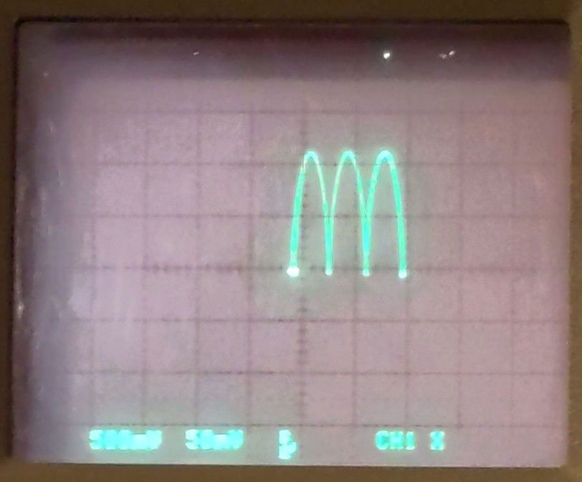Trajectory of a charge mass in an em field (omega=0,92; a*omega²=0,05; OP-time=0,21ms) | Added initial speed in x and z-direction

Potential of a charged sphere
Determine the potential of a charged sphere (radius R) with a constant internal charge density ϱ₀.
In this electrostatic application, the electric potential is given by

The Laplace-operator in spherical coordinates is defined as
Due to the spherical symmetry here, the differentiations by the angles are zero. Further simplification yields

For the implementation of this problem in an analogue engine, time will be used as variable for the radius r.
The analytical solution is

which took into account the 2 boundary conditions that φ=0 at r→∞ and that φ must be continuous at the boundary of the sphere (r=R).
Script: “TP2 10.28 Potential of a charged sphere.LACE”
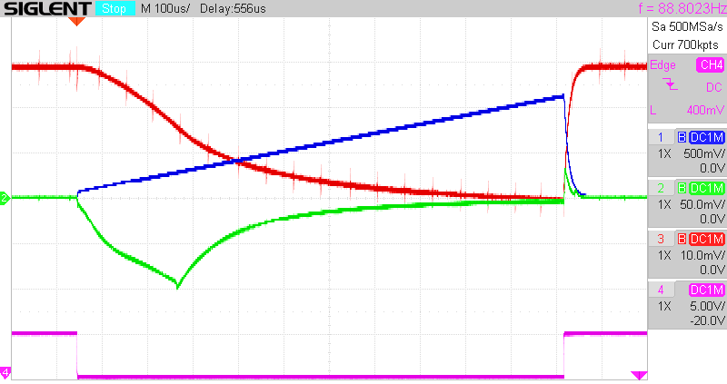
Blue curve: time ramp, which stands for the radius going from 0 to infinity.
Green: φ’. Note that φ’ is proportional to -r and changes to a 1/r² behavior once r reaches the diameter of the sphere R. The ditch at the beginning of the curve is probably an artifact due to the division by a very small r.
Red: φ. Internal to the charged sphere it follows a -r², outside a 1/r behavior. φ₀ was set such that the curve reaches 0 for high r in order to fulfill this boundary condition.
Purple: trigger
Coefficients were set as follows:
- factor0,2: 0,199, which gives about 2 with the proper weight of the integrator
- -rho0/epsilon0: 1 (arbitrarily chosen to get a nice curve)
- -phi0: 0,030 (chosen such that the curve reaches 0)
- -R: 0,238 (arbitrarily chosen to get a nice curve)
From the analytic solution we can calculate φ(r=0):

This value corresponds well to the measured value of 0,030.

Notes
Useful links:
- Solving differential equations: https://www.wolframalpha.com
- Calculating derivatives: https://www.ableitungsrechner.net/

